Exercise 1 (JAVA Environment Installation & Error Messages)
- Set up a Java development environment. In the main() method of your program try to compile the following invalid Java code snippets. Record the error messages you receive. What do you think each error message indicates?

System.out.printn(“Hello World”)
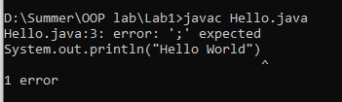
Errors
- Semicolon is missing
- ‘L’ is missing in printn

System.out.printn(Hello World)
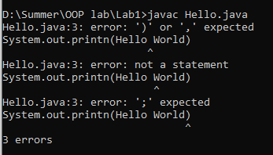
Errors
- Semicolon is missing
- In printn is incorrect it is (println) ’l’ is missing
- Double quotes are missing

System.out.println”Hello World”;
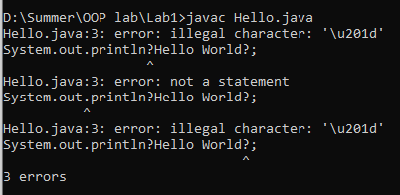
Errors
- Opening and closing parenthesis are missing
- Invalid quotes are used

println(“Hello World);
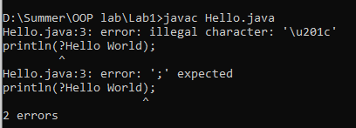
Errors
- System.out is missing
- Quotes are missing

Exercise 2 (Mathematical Expressions)
Write Java code for following mathematical expressions to compute the result.
f = 5 * 7 / 3
float f = (5 * 7) / 3.0f
int x = 5 + ‘a’
int x = 2147483647 + 1

CODE
public class Task2{

public static void main(String args[]){

int f = 5 * 7 / 3 ;
System.out.println("The result for expression 1 is : "+f);

float f1 = (5 * 7) / 3.0f ;
System.out.println("The result for expression 2 is : "+f1);

int x = 5 + 'a';
System.out.println("The result for expression 3 is : "+x);

int x2 = 2147483647 + 1;
System.out.println("The result for expresssion 4 is : "+x2);

}
}
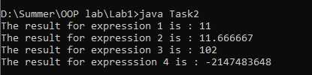

Exercise 3 (Java Variables)
Write a Java code in which create all of the primitives (except long and double) with different values. Concatenate them into a string and print it to the screen so it will print:
H3110 w0r1d 2.0 true

CODE
public class Task3{
public static void main(String args[]){

byte b =3;
short s =1;
int i =1;
int j =0;

char H ='H';
char space= ' ';
char w ='w';
char r ='r';
char d ='d';

float f =2.0f;
boolean bool = true;

System.out.println("" + H + b + s + i + j + space + w + j + r + i + d + space + f + space + bool);
}
}


Exercise 4 (Operators)
- Write Java program to allow the user to input two integer values and then the program prints the results of adding, subtracting, multiplying, and dividing among the two values. See the example below:
Enter value a:30

Enter value b:10

The result of adding is 40.

The result of subtracting is 20;

The result of multiplying is 300.

The result of dividing is 3.

CODE
import java.util.Scanner;
public class Task4{
public static void main(String args[]){

Scanner sc=new Scanner(System.in);

System.out.print("Enter value a :");
int a=sc.nextInt();

System.out.print("Enter value b :");
int b=sc.nextInt();

int add= a+b;
int sub=a-b;
int mul=a*b;
int div=a/b;

System.out.println("The result od additon is :"+add);
System.out.println("The result od subtraction is :"+sub);
System.out.println("The result od multiplication is :"+mul);
System.out.println("The result od division is :"+div);

}
}
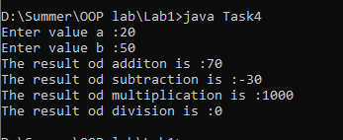

- Change the following program to use compound assignments:

Changed CODE
class ArithmeticDemo {
public static void main (String[] args){
int result = 1 + 2; // result is now 3
System.out.println(result);

result -= 1; // result is now 2
System.out.println(result);

result *= 2; // result is now 4
System.out.println(result);

result /= 2; // result is now 2
System.out.println(result);

result += 8; // result is now 10
result %= 7; // result is now 3
System.out.println(result);
}
}
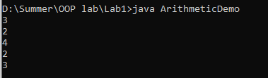

Exercise 5 (if/else & loops)
- Given Boolean variables A, B, and C, write if statements to check for the following conditions:
- A and B, but not C
- Either A, B, or C
- All or none of A, B, and C
- A and B
CODE
public class Task5{
public static void main(String args[]){

boolean A = true;
boolean B = false;
boolean C = true;

if (A && B && !C){
System.out.println("Condition 1 is true");
}

if (A || B || C){
System.out.println("Condition 2 is true");
}

if ((A && B && C) || (!A && !B && !C)){
System.out.println("Condition 3 is true");
}

if (A && B) {
System.out.println("Condition 4 is true");
}
}
}
